Chapter 3, Problem 80.

Find the nodal voltage v₁ through v₄ in the circuit in Fig. 3.120 using PSpice.

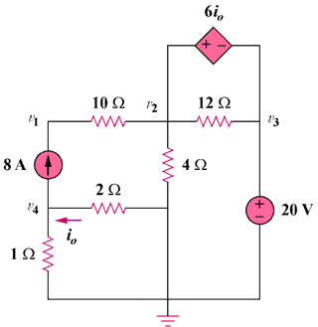

Figure 3.120
For Prob. 3.80.

